Multiplication Area Drawings and Accessible Standard Algorithms
for Multidigit Multiplication

Area drawings are powerful supports for understanding multidigit multiplication. It is helpful for students to work with areas showing each square first because many students have an incomplete understanding of area. For multidigit multiplication students need to relate their understandings of area to their understandings of place value. They need to have experiences moving from single squares for single-digit multiplication to units with values of ten (such as a 1 by 10 area) and values of 100 (such as a 10 x 10 area). Then they need to coordinate these ones, tens, and hundreds area units within an area drawing for multidigit multiplication.

Then students can move to making sketches as math drawings and labeling sides and areas so that the different units are identified. It is important for students to relate each step with the area drawing to a step in their written method. The math drawings are done so that students can make sense of the written method, so they need to discuss relationships they see.

Page 7 has a page of dots that you can print out and copy for students to begin their area and multidigit multiplication work. Page 7 has + signs beside or above or below a row or column of dots. These are spaced so that they make lengths of ten spaces. Therefore students do not have to count to make one by ten or ten by ten areas. Students will need to count to make areas of single digit lengths. Emphasize repeatedly that they are counting lengths between dots (the spaces) and not the dots themselves. Counting dots is using an array model, not an area model. We recommend using area models so that students get practice in using and understanding them.

Learning progression for students to understand area drawings and how they relate to accessible standard algorithms for multidigit multiplication

This section is taken with permission from the paper Fuson, K. C., Kiebler, S., & Decker, R. (2024). Accessible Standard Algorithms for Understanding and Equity Part 2: Multidigit and Decimal Subtraction, Multiplication, and Division. https://karenfusonmath.net/publications/

Array and area models are used in Grade 3 to show multiplication of single-digit numbers. In Grade 4 these models can be extended to show multidigit multiplication and how place values of ones, tens, and hundreds work in multiplication. An outline of major aspects of this approach are shown here. Students can work on dot paper with the dots very close together; we use lengths between dots of 4 mm. You do not need much of the dot paper because students will soon be making sketch models of multiplication problems on plain paper and relating these models to written methods.

First, students draw an area to show ones times ones. They draw the area model and then draw in the squares to show the area. Students can draw arrays or area. We suggest using area throughout because area is more difficult for students and this will give them a lot of experience with imagining the squares that make the area. It is helpful for students to write the lengths on all four sides of the rectangle to see all of the relationships involved with larger numbers.

Figure 1
Area drawings for single-digit multiplications
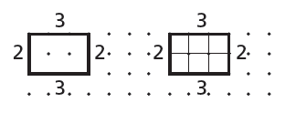

Next students draw an area model for ones times tens. They draw multiple copies of that area model and then explore and find relationships within that area model. Below are shown three patterns that are important for students to see and discuss. The third model is the crucial model because it shows the pattern ones times tens makes a tens product. The unit being counted here is a 1 x 10 rectangle.

Figure 2
Patterns in area drawings for ones times tens multiplications
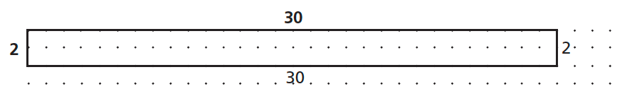

- Divide the rectangle across to show 2 groups of 30.
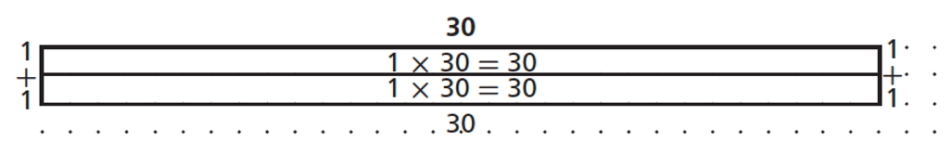

- Divide the rectangle up-and-down to show 3 groups of 20.
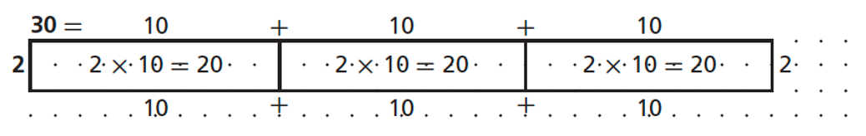

- Divide the rectangle both across and up-and-down to show 6 groups of 10. (Students need only label one of the inner rectangles.)

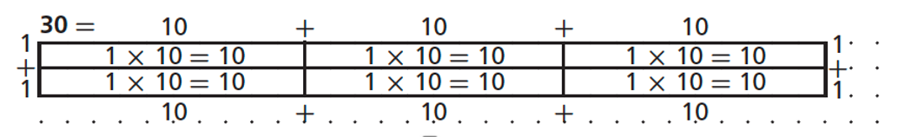

Next students need to explore the tens times tens case to see that they can make units of 100 and they get as many hundreds units as are made by the products of the digits in the tens places.

Figure 3
Units and patterns in area drawings for tens times tens multiplications

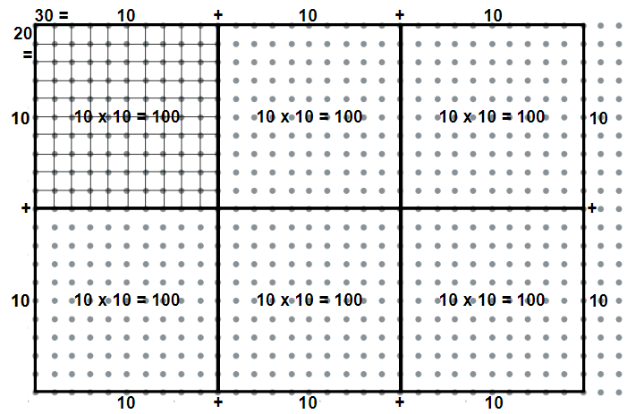

The next step is for students to discuss the patterns they see in multiplying ones times ones, ones times tens, and tens times tens. These patterns can be combined into a table and discussed. The patterns are easy because the product has as many zeroes as are in the factors. This is because each zero in the multiplying factor moves the multiplied factor one place to the left as it is multiplied by ten for the place in which each zero is. Students do need to discuss the special case of multiplying by five because it seems to violate the patterns they have just found. But this is because five times any even number ends in zero, so that adds an extra zero to the product of the places. Students can discuss how they can move from column B to column C by using the associative and commutative properties.

Table 1
Patterns in multiplications involving zeroes

Table 1
A | B | C | D
2 x 3 | 2 x 1 x 3 x 1 | 6 x 1 | 6
2 x 30 | 2 x 1 x 3 x 10 | 6 x 10 | 60
20 x 30 | 2 x 10 x 3 x 10 | 6 x 100 | 600

Most students rather quickly can move from drawing on the dot paper to making sketches on plain paper or dry erase boards in which they show the tens and the ones lengths in the factors and find the products inside each part of the area model (See Figure 11). Students can then write the totals out at the side and add them to find the total area as shown below on the right of the drawing. Because the goal of drawing a model is to stimulate a written method that makes sense as it is related to the model, students need to try writing a written method and explain and justify it by relating it to the model. Shown in the second row of Figure 11 is the Expanded Notation method developed by students so that they understand fully what they are doing. The expanded notation of 28 at the top right and the factors listed on the bottom left in blue are included initially because some students need to see these to do the correct multiplications. These steps can be dropped when students no longer need those steps, resulting in the Partial Products method. These methods are all standard algorithms because they meet the definition of using multiplication of single digits and meanings of place value.

Figure 4
Area drawings and accessible standard algorithms for ones times tens multiplications

Area Model Accessible Standard Algorithms
Place Value Sections
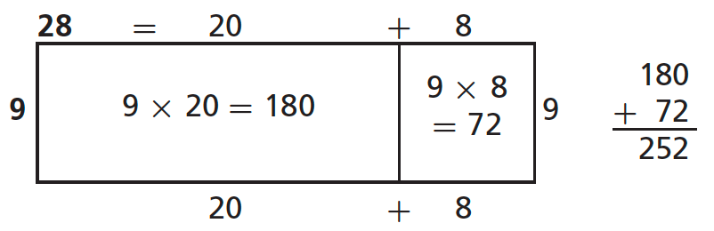

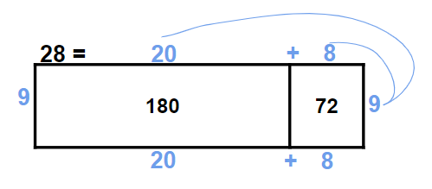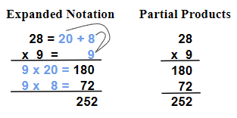

Area models to show multiplications of 2-digit times 2-digit numbers have two rows as shown in Figure 12. Initially students find it helpful to write the factors as well as the products inside the sections of the area model. But as shown in the second area model, many students soon can write the product without needing to write the factors inside the place value sections. Some students then find the product by writing the products of the place value sections out to the right and adding them. Some students do this below the written problem as shown in Figure 12. Many students can go on to the Expanded Notation and other methods shown below. But some students find the layout in all of the written methods below so difficult that they can only be accurate if they draw a quick area model, write partial products inside, and then write the totals out to the side and add them as in the Place Value Sections method.
The Expanded Notation method in Figure 12 was developed by students so that they understand fully what they are doing. The expanded notations of 43 and 67 at the top right and the factors listed on the bottom left in blue are included initially because some students need to see these to do the correct multiplications. These steps can be dropped when students no longer need those steps, resulting in the Partial Products method. These methods are all standard algorithms because they meet the definition of using multiplication of single digits and meanings of place value.
More difficult methods are showed in the bottom row of Figure 12. In these methods the top number in the area model and in the written methods is kept as a 2-digit number and only the multiplying number, here 67, is separated into its tens and ones. So the area model and the written methods all just have two rows. We call all of these standard algorithms difficult because they involve collapsed place value sections. We use the New Groups Below addition method for adding because it is the easiest addition accessible standard algorithm. The non-alternating New Groups Below multiplication method shown first is easier than the other methods because one does all multiplications first and then all additions. Also, in the written method you can see each product 7×3 = 21 and 7×4 = 28 and 6×3 = 18 and 6×4 = 24. In the other two difficult alternating methods one multiplies one place then multiplies the next place and adds in any part of the first partial product that was more than one digit. These methods are more confusing because you cannot see all of the partial products and what has been added is not so clear (such confusing digits are in red). In the final method the 1 at the very top is written in the tens place but it is actually a 1 hundred coming from the 60×3 = 180. We see no reason to introduce the difficult alternating methods to students. The expanded notation or partial products methods seem clear and sufficient for students. And for those students who need to draw the area model sketch to find the partial products, it seems much better to let them do so because it supports understanding as well as correct answers.

Figure 5
Area drawings and accessible standard algorithms for tens times tens multiplications
[This figure is on the next page.]
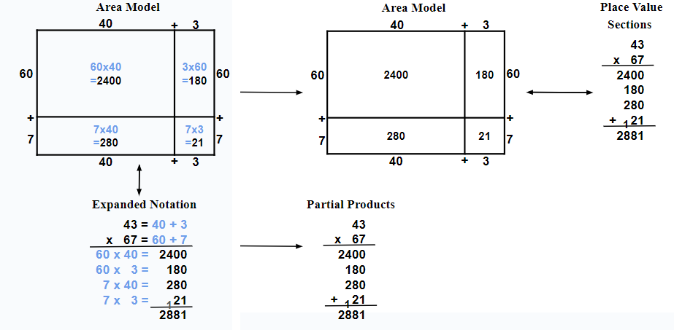
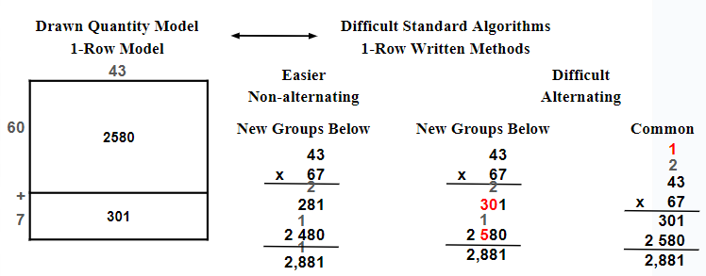

Table 2
More information about multidigit multiplication

