Adding and subtracting multidigit numbers
using math drawings and Secret Code Cards

Making math drawings can help students understand and carry out correct written methods for multidigit addition and subtraction. Manipulatives or math drawings are sometimes used first and all by themselves to find answers instead of relating each step with the math drawing or manipulatives to a written method. It is vital that students relate each step they do with their math drawing to their written method. Students also need to be able to explain each step in the math drawing and in the written method. We show in Figure 1 and Figure 2 examples of students explaining their methods. These methods are research-based accessible standard algorithms that thousands of students from all backgrounds have understood and explained. For discussion of these and other accessible standard algorithms for multidigit addition see Accessible Standard Algorithms for Understanding and Equity (Fuson, Kiebler, Decker, 2024) on the NCTM website nctm.org. For discussion of accessible standard algorithms for multidigit subtraction see Accessible Standard Algorithms for Understanding and Equity Part 2: Multidigit and Decimal Subtraction, Multiplication, and Division (Fuson, Kiebler, Decker, 2024) in Publications on karenfusonmath.net or karenfusonmath.com. Other places that discuss and demonstrate using math drawings for multidigit addition and subtraction and using these accessible standard algorithms are listed at the end of this paper.

Math drawings help students see and understand the quantities, the hundreds, tens, and ones, involved in multidigit numbers. Secret Code Cards help students maintain these quantity understandings in the face of the single digits they see in written numerals: They see 486 and not 400806. We call these Secret Code Cards because they show the secret code of numbers. These cards can be layered on top of each other to show the number as it is written in single digits (on the right below) or taken apart to see the place values in the expanded notation of the number (on the left below). The numeral side has tiny numbers on the top left so that the place-value expanded notation version is shown even when the cards are layered to just show single digits. The Secret Code Cards help students use both names for groups of ten, the English word eighty for 80 and the tens word 8 tens. The backs of the cards show hundred-boxes, ten-sticks, and ones-circles so that when these backs are layered they show math drawings such as those students draw. The drawings on the backs of the Secret Code Cards show all of the dots on each ten-stick and all of the ten-sticks in each hundred box. Math drawings made by students are simpler (see below the Secret Code Cards) so having students relate their math drawings to the backs of the Secret Code Cards is important for them to make all of the quantity connections among drawings and written numerals.

Figure 1
Secret Code Cards Fronts and Backs Unlayered and Layered and a Student Math Drawing

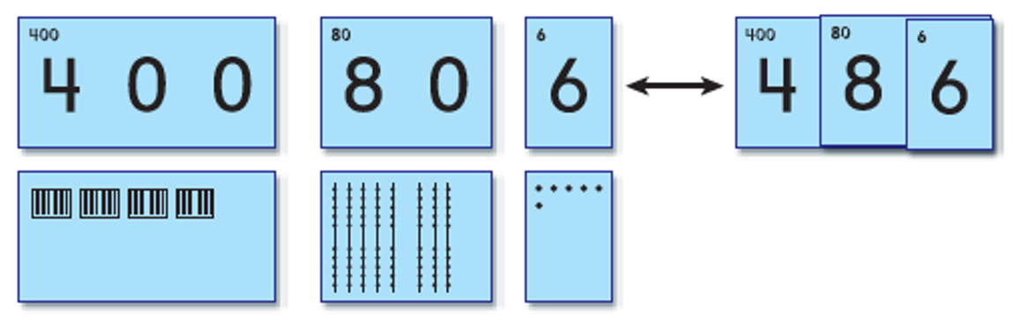

To create an inquiry environment, instead of putting pressure on students to do the method you are introducing, you can start in this way:
- I saw students in another class using this method. Let’s see if we can understand it. I will do it step-by-step and we will all try to explain each step after I do it. We will explain what happened in the math drawing and also explain what we wrote in the numerical problem. Then you all will have chances to do other problems in this way and explain it.

Figure 2
Math Drawings and Explanation of An Accessible Standard Algorithm for Multidigit Addition
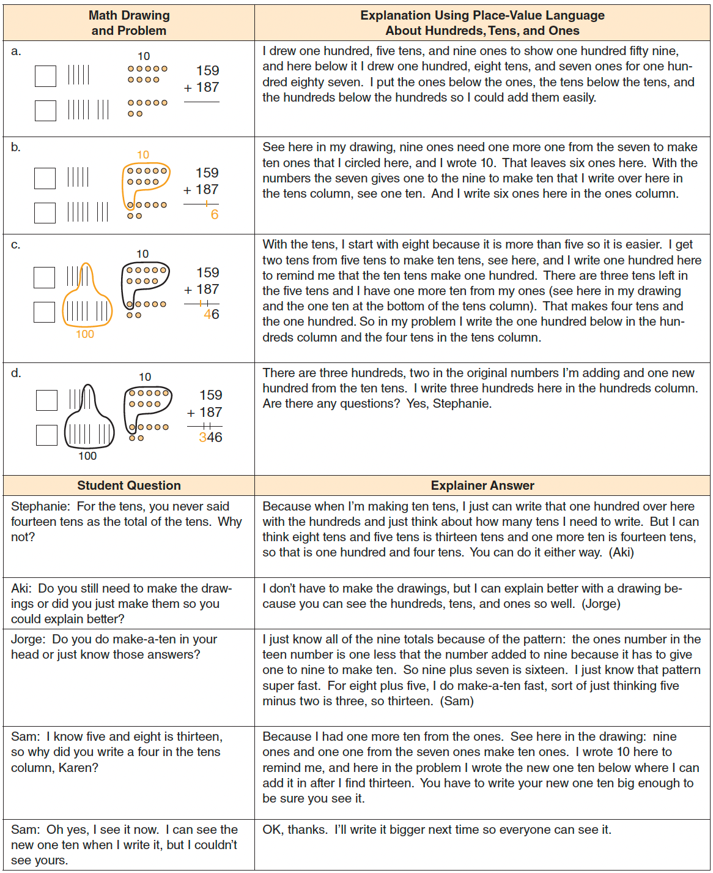 Reprinted with permission from Figure 2.21 in Teaching with Curriculum Focal Points: Focus in Grade 2, copyright 2011 by the National Council of Teachers of Mathematics. All rights reserved.

Figure 3
Math Drawings and Student Explanation of the Accessible Multidigit Subtraction Standard Algorithm Ungroup Everywhere First as Needed, Then Subtract Everywhere

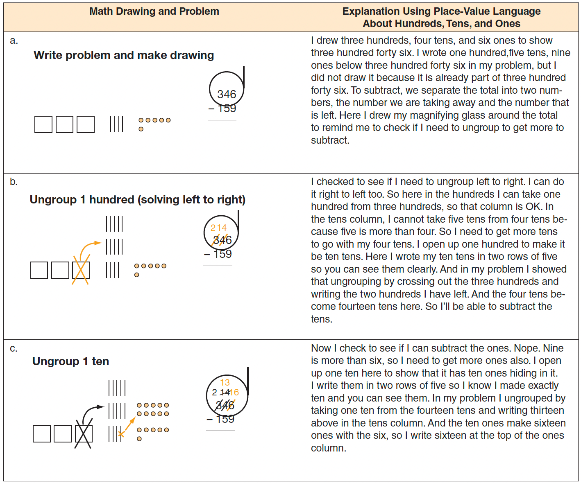
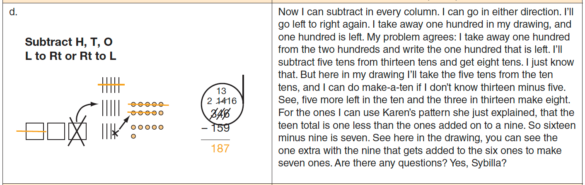
[Figure 2 is continued on the next page.]
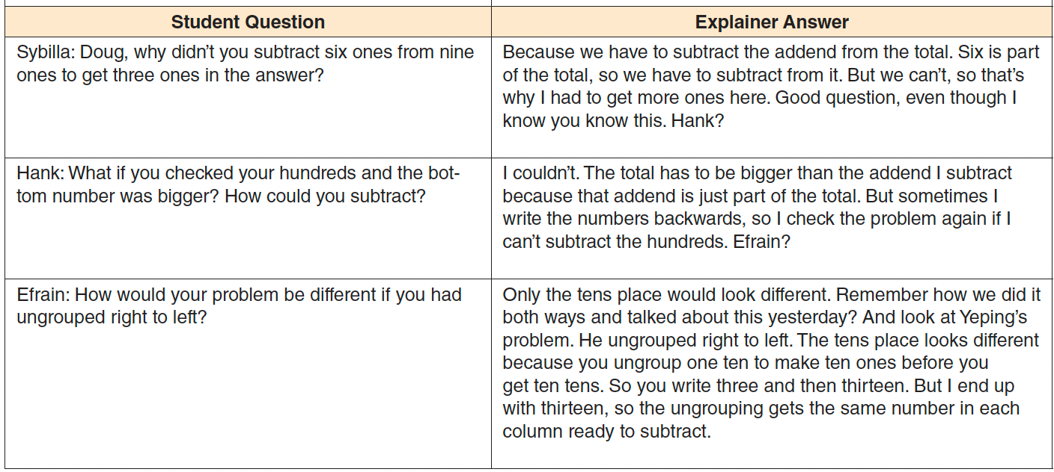 Reprinted with permission from Figure 2.22 in Teaching with Curriculum Focal Points: Focus in Grade 2, copyright 2011 by the National Council of Teachers of Mathematics. All rights reserved.

The other accessible multidigit addition algorithm is Show All Totals in which the digits in each column are added and written below the problem. Students can add from the left, which many prefer, or add from the right. Many students like this method because they can see the quantities written out symbolically as hundreds, tens, and ones. Secret Code Cards can help with this method as the numbers can be made with the cards and then unlayered to show the quantities.

Figure 4
Sow All Totals Accessible Standard Algorithm and Secret Code Cards

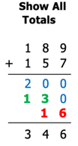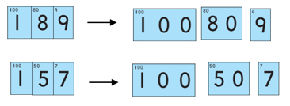

For more detailed explanations and videos of students using math drawings to solve and explain multidigit addition and subtraction using accessible standard algorithms, see these sources:

What to see | Where to go
To watch first graders explaining math drawings and three multidigit addition standard algorithms | Please go to https://karenfusonmath.net/classroom-videos/#C-Longer-Classroom-Teaching-Examples and play Grade 1
To watch Karen Fuson explaining math drawings and three multidigit addition standard algorithms along with students from several grades solving problems | Please go to https://karenfusonmath.net/classroom-videos/#B-Math-Explanations and play Multidigit Addition
To watch third graders explain 3-digit subtraction accessible standard algorithms | Please go to https://karenfusonmath.net/classroom-videos/#C-Longer-Classroom-Teaching-Examples and play G3 Multidigit Subtraction.
To watch fifth graders explain 7-digit subtraction accessible standard algorithms | Please go to https://karenfusonmath.net/classroom-videos/#G-Place-Value-and-Multidigit-Addition-and-Subtraction and play the last video G4 Explaining 7-digit subtraction.

